Automatic sprinkler based on soil moisture sensor

Masayu Anisah¹, Siswandi ², Mohammad Noer³, Nyayu Latifah H ⁴,Dwi Safitri ⁵
¹ ²³⁴⁵Electrical Engineering
State Polytechnic of Sriwijaya
Palembang, Indonesia
annisah05@gmail.com¹, c.siswandi@yahoo.co.id ², mnjphiliang@gmail.com³, nyayu_latifah@polsri.ac.id⁴, dwisafitri272@gmail.com⁵

Abstract— Plants are cultivated plants so that benefits can be taken. Plants as one living thing that is very useful for meeting human needs. Fertile soil is one of the conditions for plants to grow well. Fertility levels can be influenced by the intensity of the water they contain. For that we need to maintain the temperature and humidity of the soil under certain conditions. Currently traditional watering of plants is considered inefficient because of the length of time in watering plants and requires a lot of energy in watering plants. In overcoming this problem, in this study, the researcher will try to develop based on existing research by designing the Sensor Soil Moisture Application as a Soil Moisture Detector in the Automatic Sprinkler Control System. This tool is intended to assist users in watering plants without having to manually water them. This Automatic Plant Sprinkler Control System is one example of the application of an Arduino Uno R3 microcontroller programmed based on detection of soil moisture sensors, namely soil moisture module. When the sensor detects dry soil conditions, the tool will automatically function to water the plants. Conversely, if the soil condition is wet, the tool will not flush, so the plants can grow well because the water element needs are met at all times. This tool is also able to work when the occupants of the house are not at home, making it easier for the homeowner to water the plants and plants will still be maintained.
Keywords— Moisture Soil Sensor, Plant, Spoil Moisture, and Arduino Uno R3.

Introduction
Technological developments in a short period of time have experienced very rapid development. The development of this technology has an impact on globalization, especially on business competition, work demands, and lifestyle demands are increasing. Therefore, to compensate, humans create tools that can work more efficiently and effectively in alleviating human work.
Currently manual watering is less efficient because it can interfere with time and energy efficiency. Watering plants with excess or lack of water can also reduce durability and cause death to the plants themselves. Therefore we need a tool that can help ease the activities of watering plants in the form of a system that can work automatically. On this basis, this tool is intended to assist users in watering plants without having to be watered manually. This Automatic Plant Watering Control System is one example of the application of the application of the Arduino Uno R3 which is programmed based on the detection of soil moisture sensors. When the soil is dry, the tool will automatically water the plants. Conversely, if the soil is already wet, the appliance will not water, so plants can grow well because the water element needs are met at all times. This tool is also able to work when the householder is not at home, making it easier for homeowners in watering plants and plants will remain well groomed.
Therefore, the authors wish to conduct research on automatic sprinkler control systems using a soil moisture sensor which is a solution to the problems of agriculture in everyday life. This product is expected to be developed and assist users in watering plants without having to be watered manually.

state of the art
Research on watering plants has been done. In a previous study conducted by Almaw Ayele Aniley about Soil Moisture Sensors In Agriculture And The Possible Application Of Nanomaterials In Soil Moisture Sensors Fabrication. Furthermore, research by Praveen Barapatre about Determination of Soil Moisture using Various Sensors for Irrigation Water Management.

- previous research of plant sprinklers
Authors | Previous Research | Weakness
Almaw Ayele Aniley | Soil Moisture Sensors In Agriculture And The Possible Application Of Nanomaterials In Soil Moisture Sensors Fabrication | This method has its own limitations such as high cost, low accuracy, temperature dependent, lowresolution, calibration is ground dependent, response time is slow, installation is poor, coverage is small per sensor area, andcomplexity of operations.
Praveen Barapatre | Determination of Soil Moisture using Various Sensors forIrrigation Water Management | These sensors have a similar calibration process, but one limitation of this resistive sensor is that it can easily be out of balance.
This research was conducted by studying previous research relating to watering plants. This research is focused on soil moisture sensors that function to detect soil moisture levels and can also be used to determine whether there is water content in the soil / around the sensor.

EXPERIMENTAL SET-UP

Hardware Design
Automatic plant watering system is designed by using a soil moisture sensor to measure soil moisture that is converted to an analog voltage which will then be read by a microcontroller that has been filled with a program (embedded system). So that the tool will work in accordance with the results of research that will be conducted.
In addition, this tool is also equipped with a buzzer to find out the state of the water in the water reservoir that has a sign that the water is almost depleted. This system uses an Arduino Uno controller to control all components used.
This tool is designed in the form of three parts in the form of a box, each box has a different size. One box is designed to place the Arduino Uno controller, and other components, a second box with a larger size is designed for plants and soil moisture sensors, and a third box for a water reservoir.


Figure 1. Hardware Design Automatic Sprinkler

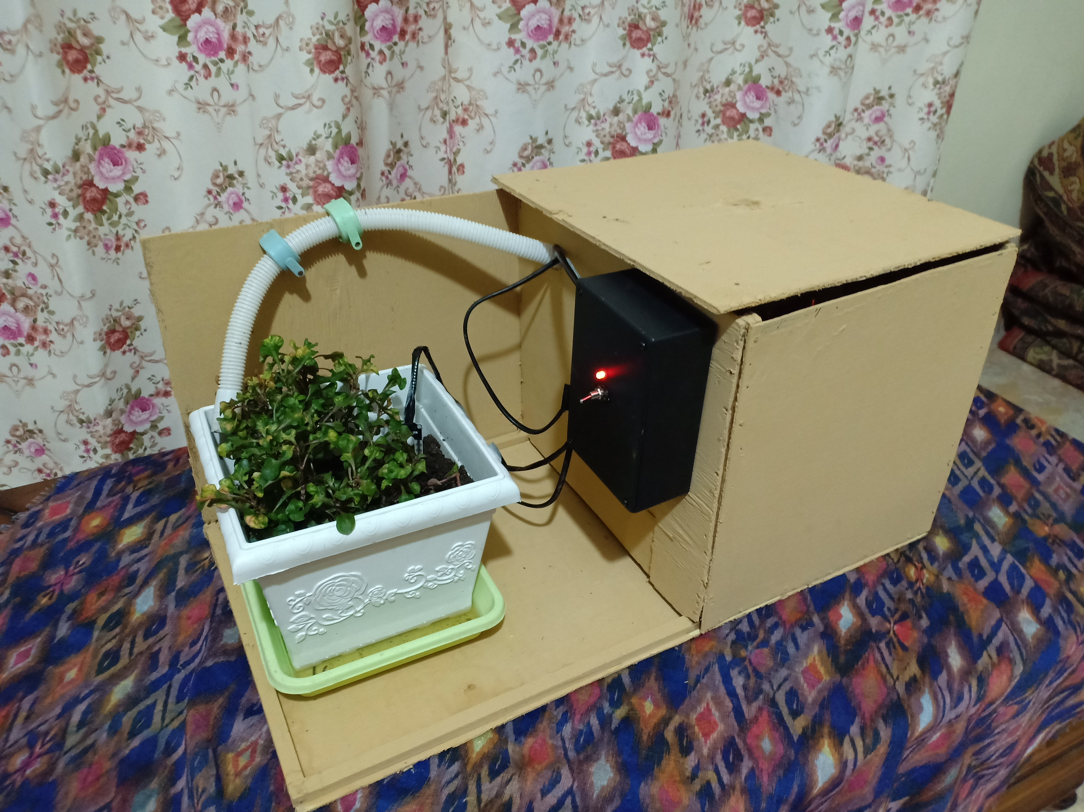

Figure 2. Device Design Automatic Sprinkler

Software Design
In figure 3 this block diagram outlines the working principle, where there is an input in the form of a soil moisture smoke sensor which is processed by the controller, the relay will activate the water pump to water the plants and after the soil conditions turn wet the relay is inactive and will turn off the water pump to stop flush. The software is designed using the C programming language for Arduino Uno.
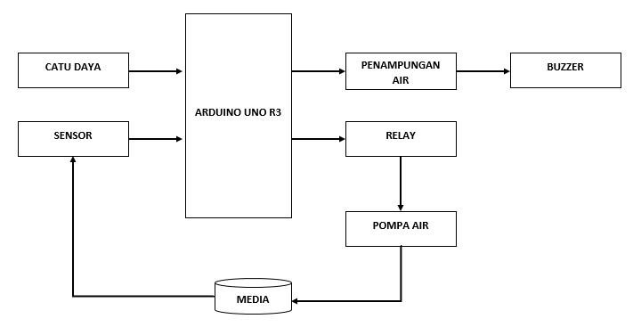
Figure 3. Diagram block Automatic Sprinkler

Real Experiment
In an open space an experiment was carried out. Experiments carried out with the natural conditions of plants to determine the work of soil moisture sensors in detecting soil moisture.

- soil moisture condition
Soil Conditions | ADC Value (Bit) | Persentage Value  (%)
Dry | 521.7-1023 | 0-49
Moist | 511.5-306.9 | 50-70
Wet | 296.7-0 | 71-100

- soil moisture value
Persentase (%) | Nilai ADC Sensor (Bit)
100 | 0.0
90 | 102.3
80 | 204.6
70 | 306.9
60 | 409.2
50 | 511.5
40 | 613.8
30 | 716.1
20 | 818.4
10 | 920.7
0 | 1023.0

Below is a graph of soil moisture values with a percentage of 0-100%.
Figure 4. Soil Moisture Value Graph

- Measuring Result automatic sprinkler
No | Time | Measuring |  | Condition
No | Time | Output ADC(Bit) | Persentage (%) | Condition
1. | 20-07-2019 | 521.73 | 49 | Dry
2. | 21-07-2019 | 531.96 | 48 | Dry
3. | 22-07-2019 | 562.65 | 45 | Dry
4. | 23-07-2019 | 542.19 | 47 | Dry
5. | 24-07-2019 | 552.42 | 46 | Dry
6. | 25-07-2019 | 542.19 | 47 | Dry
7. | 26-07-2019 | 562.65 | 45 | Dry
8. | 27-07-2019 | 521.73 | 49 | Dry
9. | 28-07-2019 | 531.96 | 48 | Dry
10. | 29-07-2019 | 542.19 | 47 | Dry

In table IV is the data obtained at the time of measurement. The data obtained is data when the sensor reads the condition of the soil in a dry state with an ADC value of 521.7-1023 and a percentage value of 0-49%. In this case, the appliance will automatically activate the pump to water the plants.
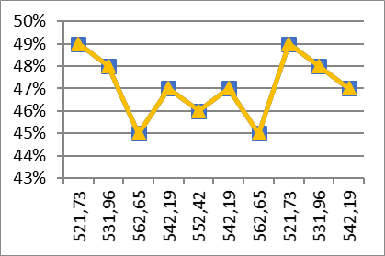

Figure 5. Measuring Result Automatic Sprinkler Value Graph

Conclusion
From this research, it can be concluded that this automatic sprinkler works using a soil moisture sensor. This automation system can water plants based on soil conditions. When the soil is dry, the tool will automatically water the plants. Conversely, if the soil is already wet, the appliance will not water, so plants can grow well because the water element needs are met at all times.

Acknowledgment
This paper is one of the requirements to complete the applied degree program of electrical engineering polytechnic of sriwijaya country. Therefore, the authors are grateful for the polytechnic of the sriwijaya country, especially in the electrical engineering department which is where the writer conducts the learning process and understand the knowledge in the field of electronics and to the two mentors who have given directions so that this paper can be completed properly.

References
[1] P. Barapatre and J. N. Patel, “Determination of Soil Moisture using Various Sensors forIrrigation Water Management,” no. 7, pp. 576–582, 2019.
[2] B. Cardenas and M. D. Dukes, “Soil moisture sensor irrigation controllers and reclaimed water; Part I: Field-plot study,” Appl. Eng. Agric., vol. 32, no. 2, pp. 217–224, 2016.
[3] Almaw Ayele Aniley, Naveen Kumar S K, and Akshaya Kumar A, “Review Article Soil Moisture Sensors in Agriculture and the possible application of nanomaterials in soil moisture sensors,” Ijaert, vol. 6, no. 1, pp. 134–142, 2018.
[4] Davis Instruments, “Soil Moisture Sensor 6440,” Thames Val., vol. 6440, p. 1, 2007.
[5] A. Garg, P. Munoth, and R. Goyal, “APPLICATION OF SOIL MOISTURE SENSORS IN AGRICULTURE: A REVIEW Calibration of VH400 Soil Moisture Sensors View project APPLICATION OF SOIL MOISTURE SENSORS IN AGRICULTURE: A REVIEW,” Water Resour. Coast. Eng., no. December, pp. 1662–1672, 2016.
[6] B. Irrigation, “Watering With Soil Moisture Sensors © 2011,” 2011.
[7] Z. Gao, Y. Zhu, C. Liu, H. Qian, W. Cao, and J. Ni, “Design and test of a soil profile moisture sensor based on sensitive soil layers,” Sensors (Switzerland), vol. 18, no. 5, 2018.
[8] N. Martin et al., “The Soil Moisture Active Passive (SMAP) Mission,” Proc. IEEE, vol. 98, no. 5, pp. 704–716, 2010.

